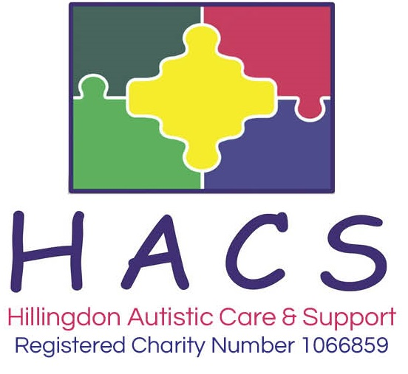

EQUALITY AND DIVERSITY POLICY

Statement of Intent

HACS is committed to meeting the needs of all individuals in a fair, respectful, and proportionate manner. Our approach to diversity and equality is to promote inclusiveness by recognising that anyone can make a positive difference in the achievement of the organisation’s vision and in the wider society. The policy applies to everyone the organisation serves, whether they are current or prospective employees, or individuals accessing our services. Diversity and equality are integral to all aspects of our work. We aim to ensure that the Charity reflects and meets the needs of our diverse community and incorporates equal opportunities in every area of our work.

The Equality Act (2010) makes it unlawful to discriminate against anyone because of a protected characteristic in a wide range of areas. The protected characteristics are:

- Age
- Disability
- Gender reassignment
- Marriage and civil partnership
- Pregnancy and maternity
- Race
- Religion and belief
- Sex
- Sexual orientation

This is not an exhaustive list and H.A.C.S. recognises that there are other groups who may face unlawful discrimination. HACS will not tolerate discrimination, bullying or victimisation of any person or organisation on grounds of any of the above characteristics or any other matter which causes a person to be treated with injustice.

Definitions

The Equality Act (2010) defines four kinds of unlawful behaviour – direct discrimination; indirect discrimination; harassment and victimisation.

Direct discrimination occurs when one person treats another less favourably, because of a protected characteristic, than they treat – or would treat – other people. This describes the most clear-cut and obvious examples of discrimination – for example if a youth club were to refuse to let a young person attend because she is a lesbian.

Indirect discrimination occurs when a “provision, criterion or practice” is applied generally but has the effect of putting people with a particular characteristic at a disadvantage when compared to people without that characteristic. An example might be holding an autism surgery on a Friday evening, which could make it difficult for observant Jewish parents to attend.

Harassment has a specific legal definition in the Act - it is “unwanted conduct, related to a relevant protected characteristic, which has the purpose or effect of violating a person’s dignity or creating an intimidating, hostile, degrading, humiliating or offensive environment for that person”. This covers unpleasant and bullying behaviour, but potentially extends also to actions which, whether intentionally or unintentionally, cause offence to a person because of a protected characteristic.

Victimisation occurs when a person is treated less favourably than they otherwise would have been because of something they have done (“a protected act”) in connection with the Act. A protected act might involve, for example, making an allegation of discrimination or bringing a case under the Act, or supporting another person’s complaint by giving evidence or information, but it includes anything that is done under or in connection with the Act. Even if what a person did or said was incorrect or misconceived, for example based on a misunderstanding of the situation or of what the law provides, they are protected against retaliation unless they were acting in bad faith. The reason for this is to ensure that people are not afraid to raise genuine concerns about discrimination because of fear of retaliation.

Implementation

Equal opportunities will be considered in all aspects of the service the organisation provides. All Trustees, staff and volunteers will be expected to promote fundamental British values of democracy; the rule of law; individual liberty and mutual respect for and tolerance of those with different faiths and beliefs and for those without faith.

Equal opportunities will be considered in all services, activities and resources. It is crucial that individuals are able to use the centre without discrimination. All equipment and activities will strive to promote positive imagery and reflect the diverse nature of our local community.

The Equality Act charities’ exception allows a charity to limit its benefits to people who share a protected characteristic. Although this may exclude (and therefore discriminates against) people with other protected characteristics, it is allowed if the charity’s governing document only allows people who share a protected characteristic to benefit, and the restriction can be justified using tests defined in government guidance. The Charity therefore exercises the right to restrict access to particular services on the ground of diagnosis of Autism Spectrum.

Recruitment

HACS is an equal opportunities and inclusive employer. Applications from people with disabilities and ethnic minorities who meet the essential criteria are actively encouraged as a diverse workforce is vital to our continued success. We particularly welcome applications from those with a diagnosis of autism or those who self-identify as autistic.

We operate a guaranteed interview scheme ensuring that anyone with a disability who meets the minimum requirements of the role is automatically shortlisted for interview during the selection process.

Induction and Training

Every new member of staff or volunteer, will receive appropriate training as part of their induction regarding their responsibilities in relation to Equality and Diversity. They will also be expected to sign a copy of the “Code of Conduct” indicating their commitment to HACS professional standards of behaviour and to respect all individuals.

Reporting Incidents of Discriminatory Behaviour

The Charity Trustees, staff and volunteers will be responsible for implementing the equal opportunities policy. Any person who observes an incident of discrimination; indirect discrimination; harassment and victimisation should report this immediately to the Chief Executive Officer. Infringements of this policy will be considered seriously, treated as a disciplinary matter under HACS disciplinary procedures, and may involve either informal or formal action depending on the seriousness of the case.

