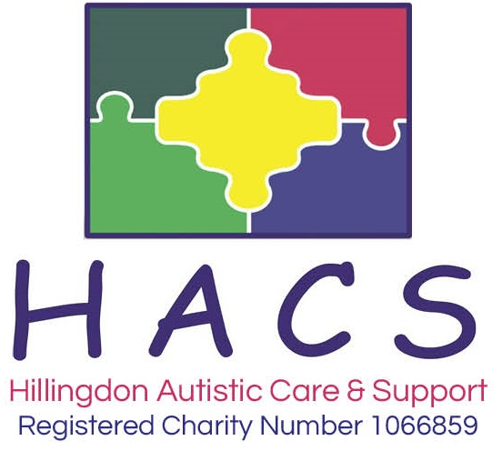

ADMISSION POLICY
CHILDREN AND YOUNG PEOPLE’S SERVICES

To ensure that each individual child and young person’s needs are met, HACS will admit children and young to the Recreation Service using the following criteria. Children and young people will:

- Have a diagnosis of Autism Spectrum (variations include Autism, Autistic Spectrum Disorder, Asperger’s Syndrome)

- Be an up-to-date member of HACS

Admission Procedure

If a child or young person has not accessed any of the Recreation Services before, a full assessment of their needs will take place. Our assessment process has three key stages:

Parent/carer interview
Observation in education setting
Paper-based assessment of EHC Plan, Support plans etc.

After the assessment has taken place, the parent/carer and child/young person will be invited to visit the setting to observe a session in progress, meet with staff and ask questions. If the parent/carer agrees to abide by all the terms and conditions of admission, including the level of fees and arrangements for payment, they will be asked to complete and sign the personal information forms to confirm their child place. Parents/carers will also be given a client confidential profile to complete.

Saturday Club Allocation & Waiting List

Places will be allocated on a fair-access basis. Therefore, parents/carers can book up to a maximum of three Saturday club sessions at any time. To ensure that admissions to the Recreation service are offered on a fair and transparent basis, the following procedure will apply to the management of waiting lists:

If, on making an enquiry about a place for their child at a particular session, a parent/carer is informed that there is not currently a suitable one available, the waiting list will be explained and then activated on the parent/carer’s behalf. Due to the fair-access booking procedures, this should take no longer than one half-term. This information will only be an estimate and will not constitute a binding guarantee from the Charity. Assessments for placements will still take place whilst a child is on the waiting list, so that they can immediately start when a place becomes available.

When a place becomes available, the Recreation Manager will contact the parent/carer whose child is suitable for the place and is highest up on the waiting list. If the parent/carer concerned no longer wishes to take up a place, the parent/carer of the next suitable child on the list will be contacted.

Playscheme

For Playschemes, parents can request as many days as they would like and places will be allocated on an equal basis. Parents will be unable to request specific dates for the Playscheme due to the high volume of requests. Parents will be asked to provide dates of pre-booked holidays or other holiday clubs they have booked so that these can be reasonably avoided. Places will be secured only on receipt of completed documentation and payment for the place.

Youth Club

Once a young person’s initial assessment is complete, the weekly Wednesday and Thursday youth clubs are open-access sessions. Pre-booking is not required for these sessions.

Saturday Club & Playscheme Fees

The Charity understands that the cost of our services may seem expensive to a parent/carer. However, our services are heavily subsidised. There is a high cost associated with providing a high quality, safe and stimulating service for autistic children, particularly due to the high staff ratios required.

Parents/carers are encouraged to speak to a member of management if they have any query about the fees policy, or if, for any reason they are likely to have difficulty in making a payment on time. Parents/carers are strongly advised to arrange a meeting at the earliest possible opportunity, to avoid jeopardising their child’s place. The management team are able to offer easy-payment terms to reduce financial pressures on families.

